**Attachment D – Existing LEP Maps**

***Figure 1:*** *Willoughby LEP 2012 Land Zoning map LZN_004 (source: NSW Legislation)*

***Figure 2:*** *Willoughby LEP 2012 Maximum Height of Buildings map HOB_004 (source: NSW Legislation)*

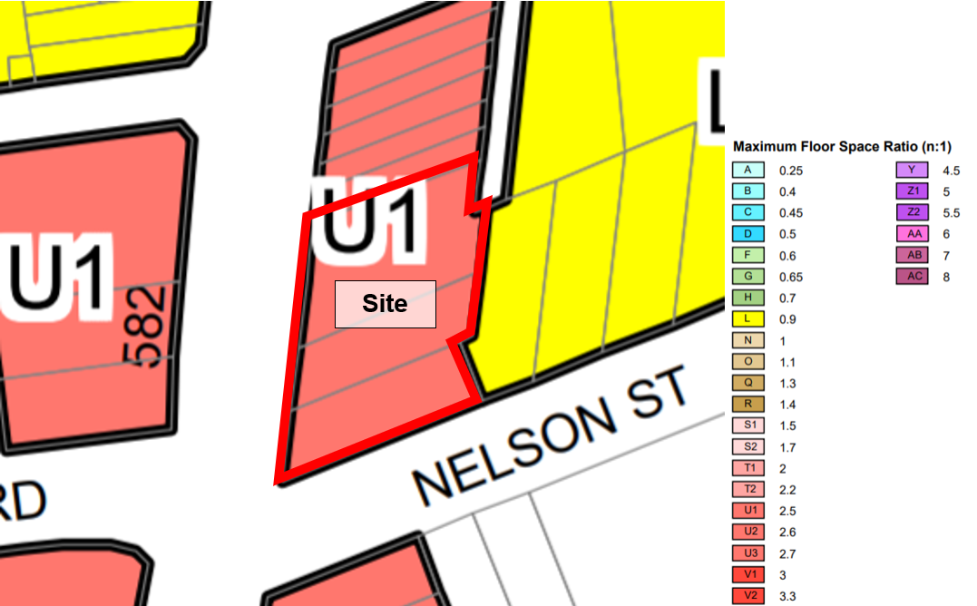***Figure 3:*** *Willoughby LEP 2012 Maximum FSR map FSR_004 (source: NSW Legislation)*